CSA1505-Cloud computing and big data analytics
Experiment-3
Create a simple cloud software application for Car Booking Reservation System using any Cloud Service Provider to demonstrate SaaS include the necessary fields such as search for cabs, from, to, rental , out station, Package type, hours/Days etc.

Car Booking Reservation SaaS Application:
Aim
To design and deploy a Car Booking Reservation System on a cloud platform (Zoho Creator) to demonstrate Software as a Service (SaaS), where customers can book cars and administrators can manage reservations online.

Procedure
Step 1: Login to Cloud Provider
- Open Zoho Creator and log in with your Zoho account.
Step 2: Create a New Application
- Click Create Application → From Scratch.
- Name the app: Car Booking Reservation System.
Step 3: Build Forms (Input Screens)
- Car Details Form
  - Car ID (Auto-number)
  - Car Model (Text)
  - Car Type (Dropdown: Sedan, SUV, Hatchback, etc.)
  - Availability Status (Dropdown: Available / Booked)
  - Price per Day (Number)
- Customer Booking Form
  - Customer Name (Text)
  - Email (Email)
  - Phone (Phone)
  - Car (Lookup from Car Details Form)
  - Booking Start Date (Date)
  - Booking End Date (Date)
Step 4: Create Reports (Data Views)
- Available Cars Report → Shows cars with status = Available.
- Booking Report → Lists all customer reservations with details.
Car Booking Reservation SaaS Application:
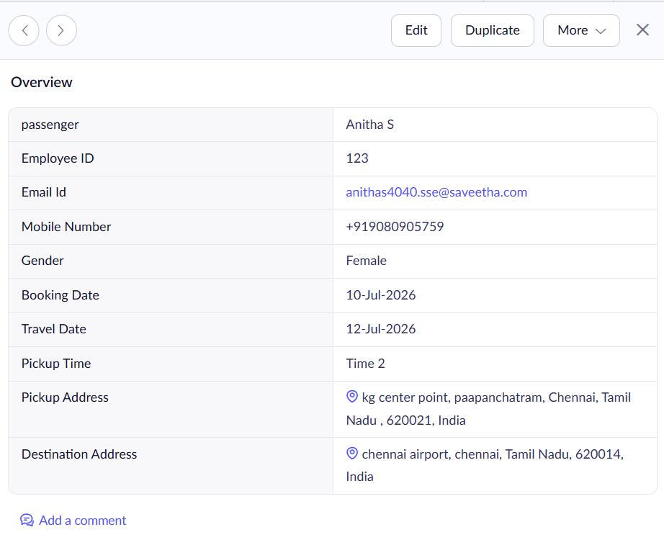
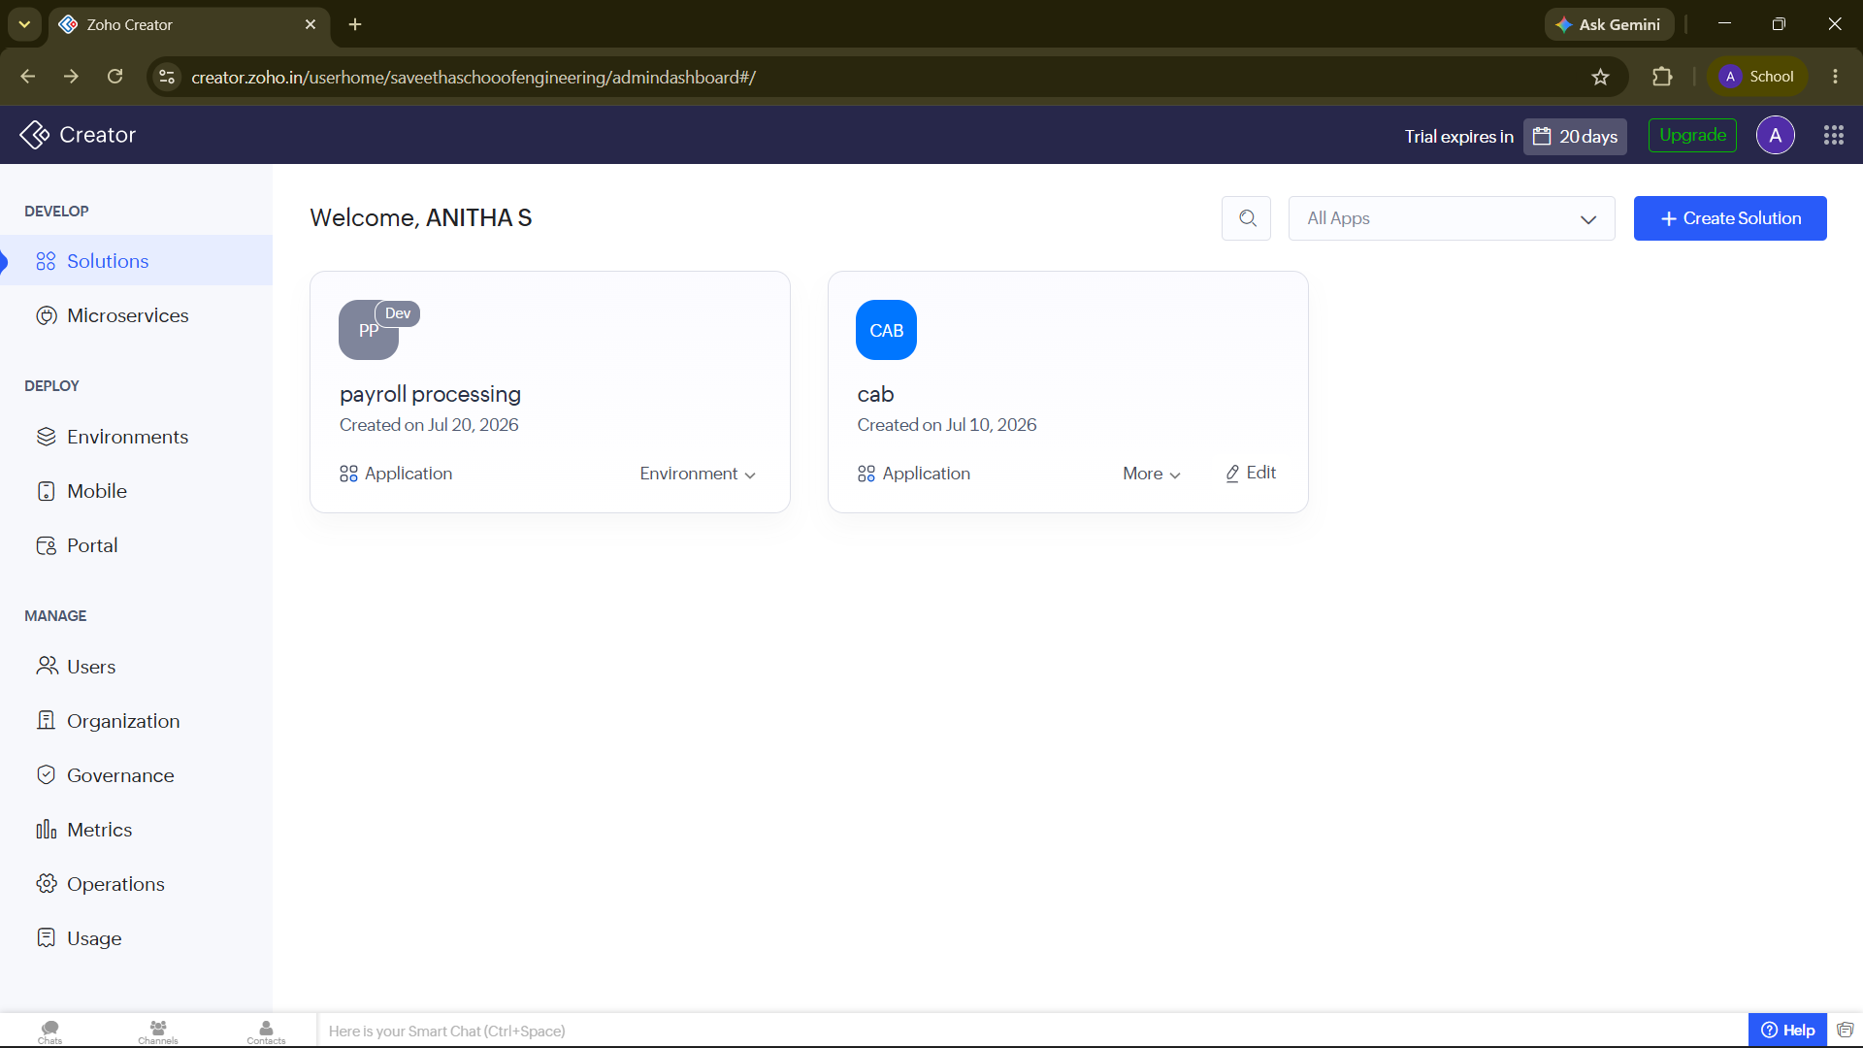

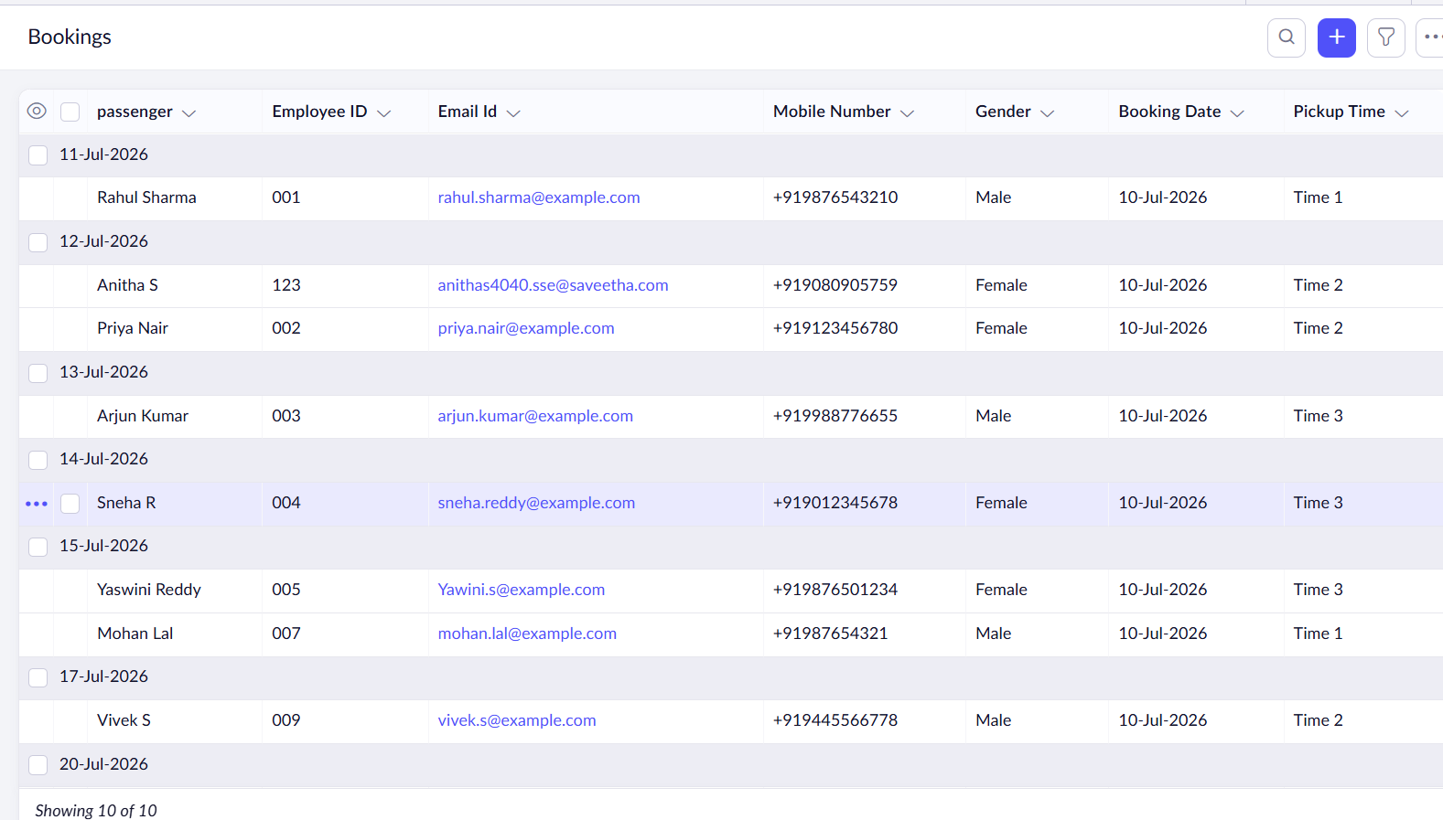
Result
- A Car Booking Reservation SaaS Application was successfully created and deployed on Zoho Creator.
- Customers can view available cars, book them for a date range, and receive booking confirmations.
- Car availability is automatically updated in the system.
The app is hosted on Zoho’s cloud platform and accessible via the internet, fulfilling the definition of Software as a Service (SaaS).

